**Date: 02-03-2020**

**Author-MD Fakrul Islam**

[**fakrul.islam@tsi.com.bd**](mailto:fakrul.islam@tsi.com.bd)

**Optimization and Inferencing using Intel distributed OpenVino Toolkit (Intel® DevCloud)**

**\*\*\*\*\*Note**

**The optimization and inferencing computation requires an active account in Intel® DevCloud. All the examples were shown from the account of, “u37452-fakrul.islam@tsi.com.bd”**

**Optimization in Intel® DevCloud:**

# Step 1:

Go to the link, <https://devcloud.intel.com/edge/home/> and login using your credentials.

# Step 2:

Click Advanced -> Connect and Create

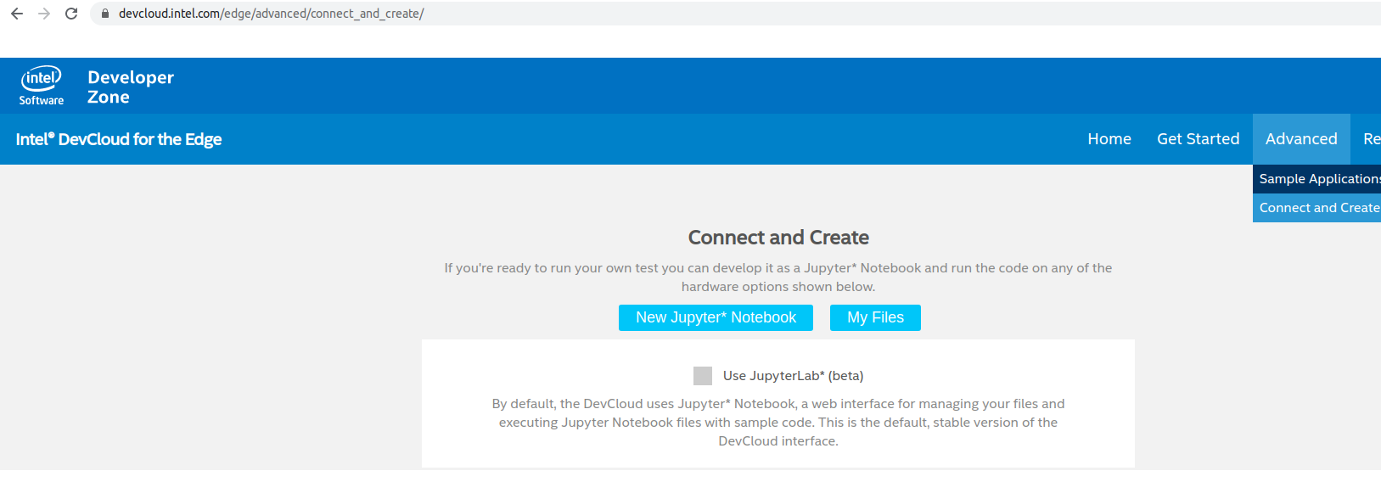

# Step 3:

Click MyFiles -> Launch Server

# Step 4:

Create Directory/Folder of names below in the location of:

u37452@s099-n003:~$ pwd

/home/u37452

1. Model_32 #Model developed by images of 32*32 pixels(3 color channels).
2. Model_64 #Model developed by images of 64*64 pixels(3 color channels).
3. Model_128 #Model developed by images of 128*128 pixels(3 color channels).
4. Model_224 #Model developed by images of 128*128 pixels(3 color channels).

#Step 5:

Upload TensorFlow models in the corresponding directory. For example, if you develop the model by 32*32 images then upload the TensorFlow model in the directory of /home/u37452/Model_32.

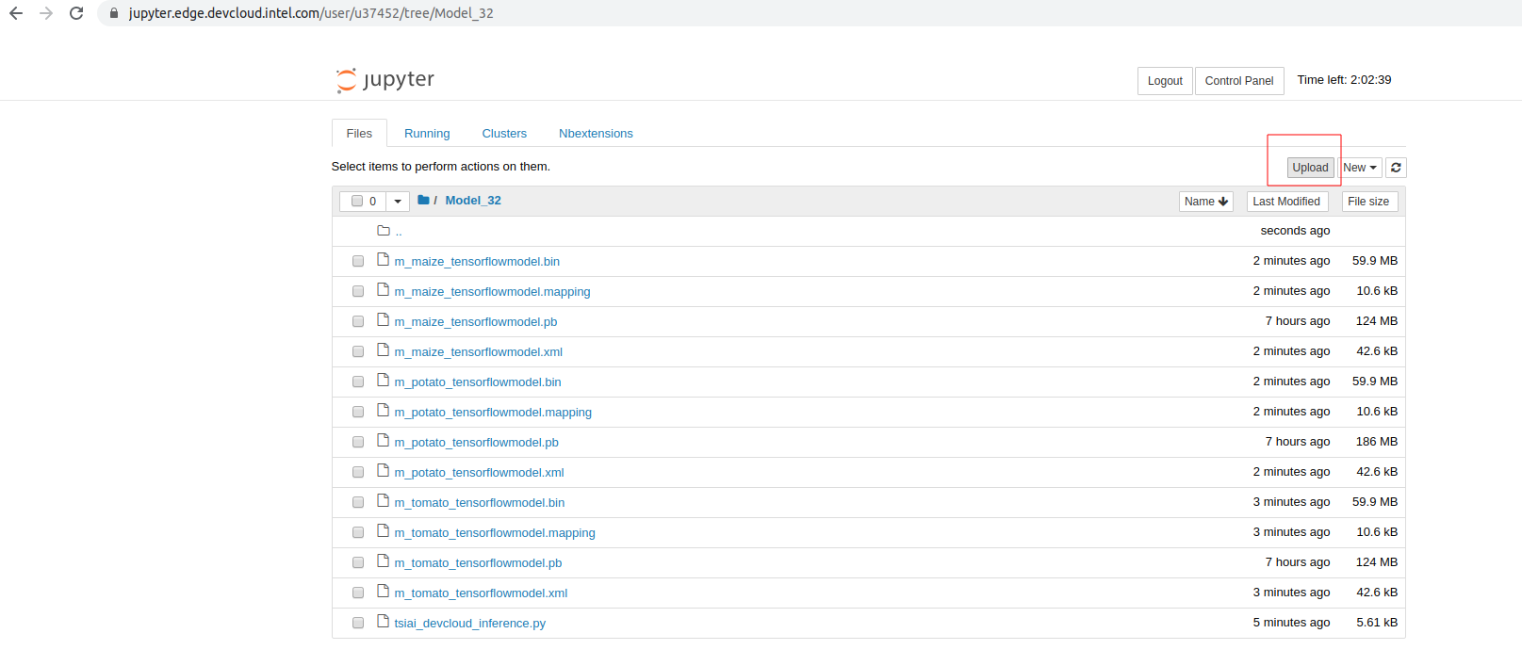

#Step 6: Optimization of models in the dev cloud edge

1. To optimize tomato model(m_tomato_tensorflowmodel.pb) run this command,

**u37452@s099-n003:~/Model_32$ /opt/intel/openvino/deployment_tools/model_optimizer/mo_tf.py --input_model /home/u37452/Model_32/m_tomato_tensorflowmodel.pb --data_type FP32 --input_shape [1,32,32,3] --output_dir /home/u37452/Model_32/**

You will get the following response:

[ SUCCESS ] Generated IR version 10 model.

[ SUCCESS ] XML file: /home/u37452/Model_32/m_tomato_tensorflowmodel.xml

[ SUCCESS ] BIN file: /home/u37452/Model_32/m_tomato_tensorflowmodel.bin

[ SUCCESS ] Total execution time: 5.71 seconds.

[ SUCCESS ] Memory consumed: 830 MB.

Please find that corresponding IR, BIN and Mapping files are generated.

1. To optimize potato model(m_potato_tensorflowmodel.pb) run this command,

**u37452@s099-n003:~/Model_32$ /opt/intel/openvino/deployment_tools/model_optimizer/mo_tf.py --input_model /home/u37452/Model_32/m_potato_tensorflowmodel.pb --data_type FP32 --input_shape [1,32,32,3] --output_dir /home/u37452/Model_32/**

You will get the following response

[ SUCCESS ] Generated IR version 10 model.

[ SUCCESS ] XML file: /home/u37452/Model_32/m_potato_tensorflowmodel.xml

[ SUCCESS ] BIN file: /home/u37452/Model_32/m_potato_tensorflowmodel.bin

[ SUCCESS ] Total execution time: 5.77 seconds.

[ SUCCESS ] Memory consumed: 1126 MB.

Please find that corresponding IR, BIN and Mapping files are generated.

1. To optimize maize model(m_maize_tensorflowmodel.pb) run this command,

**u37452@s099-n003:~/Model_32$ /opt/intel/openvino/deployment_tools/model_optimizer/mo_tf.py --input_model /home/u37452/Model_32/m_maize_tensorflowmodel.pb --data_type FP32 --input_shape [1,32,32,3] --output_dir /home/u37452/Model_32/**

You will get the following response

[ SUCCESS ] Generated IR version 10 model.

[ SUCCESS ] XML file: /home/u37452/Model_32/m_maize_tensorflowmodel.xml

[ SUCCESS ] BIN file: /home/u37452/Model_32/m_maize_tensorflowmodel.bin

[ SUCCESS ] Total execution time: 5.25 seconds.

[ SUCCESS ] Memory consumed: 830 MB.

Please find that corresponding IR, BIN and Mapping files are generated.

**Inferencing in Intel® DevCloud:**

Step 1:

1. Download the script, tsiai_devcloud_inference.py from git, <https://github.com/tsiAILAB/Plant-Pathology>
2. Download PHL.JPG, MHL.JPG and TLB.JPG from git,

<https://github.com/tsiAILAB/Plant-Pathology>

1. Download potato.labels, tomato.labels and maize.labels from git,

<https://github.com/tsiAILAB/Plant-Pathology>

Step 2:

1. Upload the script, tsiai_devcloud_inference.py at /home/u37452/Model_32
2. Upload PHL.JPG, MHL.JPG and TLB.JPG at /home/u37452/Model_32
3. Upload potato.labels, tomato.labels and maize.labels at /home/u37452/Model_32

Step 3:

1. Inferencing the tomato Model. Please give the following command

**u37452@s099-n003:~/Model_32$ python3 tsiai_devcloud_inference.py -m "m_tomato_tensorflowmodel.xml" -i "TLB.JPG" -d "CPU" --labels "tomato.labels" -nt "5"**

You will get the output,

[ INFO ] Creating Inference Engine

[ INFO ] Loading network files:

m_tomato_tensorflowmodel.xml m_tomato_tensorflowmodel.bin

[ INFO ] Preparing input blobs

[ WARNING ] Image TLB.JPG is resized from (256, 256) to (32, 32)[ INFO ] Batch size is 1

[ INFO ] Loading model to the plugin

[ INFO ] Starting inference in synchronous mode[ INFO ] Processing output blob

[ INFO ] Top 5 results:

Image TLB.JPG

classid probability

------- -----------

1="LateBlight" 0.9993267

0="EarlyBlight"0.0006714

2="LeafCurl"0.0000017

3="LeafMold"0.0000002

4="Healthy"0.0000000

Please find that “**Tomato Late Blight**” is successfully identified having the highest probability.

1. Inferencing the potato Model. Please give the following command.

**u37452@s099-n003:~/Model_32$ python3 tsiai_devcloud_inference.py -m "m_potato_tensorflowmodel.xml" -i "PHL.JPG" -d "CPU" --labels "potato.labels" -nt "3"**

You will get the output,

[ INFO ] Creating Inference Engine

[ INFO ] Loading network files:

m_potato_tensorflowmodel.xml m_potato_tensorflowmodel.bin[ INFO ] Preparing input blobs

[ WARNING ] Image PHL.JPG is resized from (256, 256) to (32, 32)

[ INFO ] Batch size is 1[ INFO ] Loading model to the plugin[ INFO ] Starting inference in synchronous mode

[ INFO ] Processing output blob

[ INFO ] Top 3 results:

Image PHL.JPG

classid probability

------- -----------

2="Healthy" 0.9689326

1="LateBlight"0.0310673

0="EarlyBlight"0.0000000

Please find that “**Potato Healthy Leaf**” is successfully identified having the highest probability.

1. Inferencing the maize model. Please give the following command.

**u37452@s099-n003:~/Model_32$ python3 tsiai_devcloud_inference.py -m "m_maize_tensorflowmodel.xml" -i "MHL.JPG" -d "CPU" --labels "maize.labels" -nt "4"**

You will get the output,

[ INFO ] Creating Inference Engine

[ INFO ] Loading network files:

m_maize_tensorflowmodel.xml

m_maize_tensorflowmodel.bin

[ INFO ] Preparing input blobs

[ WARNING ] Image MHL.JPG is resized from (256, 256) to (32, 32)

[ INFO ] Batch size is 1

[ INFO ] Loading model to the plugin

[ INFO ] Starting inference in synchronous mode

[ INFO ] Processing output blob

[ INFO ] Top 4 results:

Image MHL.JPG

classid probability

------- -----------

3="Healthy" 1.0000000

0="CommonRust" 0.0000000

1="GrayLeafSpot" 0.0000000

2="NorthernLeafBlight" 0.0000000

Please find that “**Maize Healthy Leaf**” is successfully identified having the highest probability.